**COVID19: Impact on patients in Skill Rehabilitation Unit with and without**

**Metabolic Syndrome**

Ernest Maina DNP, APRN, FNP-C

Wichita State University

04/07/2022

DNP Project Proposal Committee.

Chair: Jamie Harrington, DNP, APRN, CNM, FNP-BC

Member: Debie Pile, DNP, APRN, CNS

**Table of Contents**

Section 1: Abstract……………………………………………………………………...3

Background………………………………………………………………........5

Literature review……………………………………………………………....6

Factors Contributing to Metabolic Syndrome………………………………....6

COVID19 Literacy…………………………………………………………….8

Section 2: Model and Framework

Theoretical Framework………………………………………………………...11

Project purpose…………………………………………………………………11

Project question………………………………………………………………...11

Section 3 Project Design and Methods………………………………………………... 12

Design, Population, Sample, Setting …………………………………………...12

Procedure……………………………………………………………………………… 13

Conclusion……………………………………………………………………………. 17

Nursing Implication…………………………………………………………………… 17

Ethical Considerations…………………………………………………………………18

Reference ………………………………………………………………………………19

Appendix……………………………………………………………………………… 28

**Acknowledgments**

First and foremost, I give God the praises for helping me through this journey. I give my sincere gratitude to my committee chair and member, Dr. Jamie Harrington and Dr. Debie Pile. I couldn’t have done any of this without you. Your guidance, patience, encouragement, and support in the last year gave me the resilience to complete this program. I am truly thankful, to the entire faculty and team at the Wichita State University’s Executive Leadership Doctor of Nursing Practice program, I thank you for your endless support. Words cannot express my gratitude and appreciation that I have for my wife, Amanda D. Maina, you have always been my number one fan and support. Our son Dakota Maina and daughter Kenya Maina, I am forever grateful for the support you gave me every step of the way. I am blessed to have each one of you in my life.

**Dedication**

I dedicate this project to my late mother Monica Nduta Maina, who was an ever-present pillar of support through out my journey, in failures and accomplishments.

**Abstract**

**Importance:** Metabolic syndrome (MS) is a common comorbidity in patients with severe COVID-19, yet little is known about the Impact of COVID 19 in patients in a Skill Rehabilitation Unit with and without Metabolic Syndrome.

**Objective:** To determine the impact of COVID 19 in patients in the Skill Rehabilitation Unit with and without Metabolic Syndrome.

**Design, Setting, and Participants:** A retrospective review of electronic charts was used to compare patients’ diagnoses with and without MS who contract COVID-19. The target population was both male and female patients aged 60-100, of Caucasian, Hispanic, and African American descent in a skilled rehab facility in the Midwest with a COVID-19 diagnosis. The setting was a skilled rehabilitation facility with an 80-bed capacity, a designated 20-bed COVID-19 wing, and private patient rooms. A retrospective chart review was completed on patients who met the criteria of a diagnosis of COVID-19 from 2020 and 2021 to gather the data. Inclusion criteria for MS patients were based on the Adult Treatment Panel III criteria (Alexander, et al., 2003) Adult treatment panel III in Table 2 Appendix J. The inclusion criteria included a diagnosis of three or more diagnoses based on ICD10 that includes: Hypertension (HTN), diabetes mellitus 2 (DM2), hyperlipidemia (HLD), coronary artery disease (CAD), or obesity. The exclusion criteria were patients aged less than 60 years old or greater than 100 years old.

**Exposures:** Exposures were COVID-19 infection, metabolic syndrome, and the inclusion criteria of three or more diagnosis based on ICD10 that includes: Hypertension (HTN), diabetes mellitus 2 (DM2), hyperlipidemia (HLD), coronary artery disease (CAD), or obesity.

**Main Outcomes and Measures:** The primary outcome was a skilled rehabilitation unit mortality. Secondary outcomes included long-term oxygen dependency, chronic liver failure and/or debility,

**Results:** Thirty-five patients met criteria for the study. After considering eligibility criteria, the researcher included 14 confirmed cases of COVID‐19 patients who also met criteria for an MS diagnosis through Adult Treatment Panel III criteria found in Table 4 appendix L. Twenty-one patients had COVID-19 but did not meet diagnosis criteria for MS found in Table 5 appendix M. The median age of participants with MS was 85 years old and non-MS was 68 years old. 27 (77.1%) were women and 8 (22.9%) were men. The overall sample prevalence of MS patients was 40% (14/35) and non-MS patients were 60% (21/35). Patients with MS had poorer outcomes which included 5 (1 male, 4 females) deaths, 3 females long-term oxygen dependency, and 7 (1 male, 6 females) with debilities. Retrospective review of all 35 patients’ charts showed that COVID‐19 patients with pre‐existing MS based on diagnosis through Adult Treatment Panel III criteria had higher odds of poorer outcomes compared to better outcomes with a pooled odds ratio (OR) of 1.88 (95% CI: 1.25–2.80; p = .002). There was an 89% heterogeneity between chart studies (p ≤ .001). An analysis by the proportion of comorbidities, significant heterogeneities were observed for estimates of hypertension, hyperlipidemia, and DM2 (p = 0.00), but not for obesity by itself (p = 0.209).

**Conclusions and Relevance:** Underlying evidence strongly supports those diseases such as hypertension, diabetes, hyperlipidemia, obesity, cardiovascular disease, and their susceptibility to conditions may be linked to the pathogenesis of COVID -19. This study, although limited, further concludes that an underlying diagnosis of MS can increase risk of COVID-19 morbidity and mortality.

**COVID19: Impact on patients in Skill Rehabilitation Unit with and without Metabolic Syndrome.**

**Background.**

About 25% of the adults in the United States have metabolic syndrome (MS), which accounts for the premature occurrence of cardiovascular mortality (Saklayen, 2018). MS is the underlying cause of a plethora of disorders that include cardiac disorders, diabetes mellitus (DM), hypertension and depression (Saklayen, 2018). Diseases associated with MS are major causes of morbidity and mortality (Mendrick, et al., 2018). According to the American Heart Association (AHA) (2016), MS is a serious health condition that increases the risk of cardiovascular disease (CVD), DM, stroke, and diseases related to fatty buildup in artery walls. Not only does MS increase mortality and morbidity, but it has created a financial burden to the nation’s budget. The total costs of medical care are 20% higher among patients with MS ($40,873 vs. $33,010) (Shukla, et al., 2017). The two simple forces attributing to this disorder are increased consumption of high calorie-low fiber fast food and the decrease in physical activity (Saklayen, 2018). According to Gordon (2020), rates of MS are increasing. The rate of MS among adults ages 20 to 39 increased from 16% in 2011-2012 to 21% in 2015-2016, and for adults over age 60 it went from 47% to 50%. These rates equate to increased risk of conditions such as heart disease and diabetes (Gordon, 2020). Advanced practice registered nurses (APRNs) can impact patient out comes through patient education and managing patient comorbidities which are related to MS. Reversing or management of MS can be determined by improvement in hemoglobin a1c (Hgba1c), systolic blood pressure, and lipid levels.

**Literature Reviews**

**Diagnostic Criteria for MS.**

The National Cholesterol Education Program (NCEP) provided a definition for MS in 2001 known as the Adult Treatment Panel III criteria. “The NCEP ATP III defined MS as the presence of three or more of the following risk determinants: 1) increased waist circumference (>102 cm [>40 in] for men, >88 cm [>35 in] for women); 2) elevated triglycerides (≥150 mg/dl); 3) low HDL cholesterol (<40 mg/dl in men, <50 mg/dl in women); 4) hypertension (≥130/≥85 mmHg); and 5) impaired fasting glucose (≥110 mg/dl)” (American Medical Association, 2001).

**Factors Contributing to Metabolic Syndrome.**

Serum levels including fasting blood glucose (FBG), low density lipoprotein (LDL), fasting triglyceride (TG) and high-density lipoprotein (HDL) levels were directly linked to development of MS (Mohammadbeigi, et al., 2018). Overproduction of very-low-density lipoprotein remnants with apolipoproteins B-100, small low-density lipoprotein particles, and reduced levels of high-density lipoprotein cholesterol are the primary dyslipidemic abnormalities of MS patients. The research also shows that there is a long-standing association existing between elevated triglycerides and cardiovascular disease (CVD) (Lopez-Candales, et al., 2017)

The most common prevalent metabolic abnormalities associated with MS were low high-density lipoprotein cholesterol (<40 mg/dL), a waist circumference >102 cm, blood pressure ≥130/85 mmHg, (TG) ≥150 mg/dL, and FBG ≥110 mg/dL. FBG was the most important factor contributing to MS, and all elements of the lipid profile showed important associations with MS (Mohammadbeigi, et al., 2018).

Another study investigated correlation between the level of high-density lipoprotein (HDL) and the incidence of MS; components that tend to develop at each level of HDL; and how these components change with time. The results of this study showed that incidence of MS increased with the reduction of HDL over time. Participants with high normal and normal HDL were less susceptible than people with higher HDL were to developing MS (Liu et al., 2015; Fan, et al., 2019).

Obesity and a sedentary lifestyle were also linked to the development of MS. According to Gierach, et al., (2014) waist circumference is a crucial factor when it comes to diagnosing MS. According to the 2005 International Diabetes Foundation (IDF)criteria, subsequently revised in 2009, abdominal obesity is identified as the waist circumference of ≥80 cm in women and ≥94 cm in men. It is responsible for the development of insulin resistance. The aim of the study by Gierach, et al., was to demonstrate a correlation between waist circumference (WC) and body mass index (BMI) in patients with MS in relation to hypertension, lipid disorders, and carbohydrate disorders.

Research shows that epigenetics has a bigger role in promoting MS (Saklayen, 2018). Parental obesity may cause obesity in the offspring through epigenetic changes in the spermatozoa or oocytes or more commonly in utero environments (Saklayen, 2018). In one of the research studies, an obese mother or father who underwent bariatric surgery prior to conception had children less prone to obesity/ MS than children born prior to bariatric surgery of parent(s) (Saklayen, 2018). Epidemiological studies have shown that there is a strong association between intrauterine nutrition, patterns of postnatal nutrition, and growth and MS in adults. Mechanistically, this phenomenon seems to occur through decreased DNA methylation of the imprinted IGF2 gene in the offspring and hypermethylation of two obesity-related genes—leptin and tumor necrosis factor (TNF). These epigenetic changes affect growth factors, adipogenesis, appetite control, and glucose homeostasis in the offspring (Saklayen, 2018).

**Role in Development of Diabetes and Cardiovascular Disease (CVD)**

MS has been noted to be an important clinical tool to predict diabetes and CVD (Shin, et al., 2013). To predict diabetes and CVD the researchers’ used markers of abnormal glucose metabolism or insulin resistance, plus at least two of four MS risk factors, which included obesity, hypertension, elevated triglycerides and/ or reduced HDL cholesterol, and microalbuminuria. MS is immensely useful as a clinical tool to predict diabetes and CVD, especially in high-risk groups with MS and impaired fasting glucose (IFG). Exclusion of DM in MS is important to maximize the prevention effect of CVD with preceding DM.

Insulin resistance is defined as an impaired biologic response to insulin stimulation of specific target tissues, which include the liver, muscle, and adipose tissue (Freeman & Pennings, 2021). Insulin resistance is thought to precede the development of DM by 10 to 15 years. The development of insulin resistance usually results in a compensatory increase in endogenous insulin production. Insulin resistance results in weight gain which, in turn, exacerbates insulin resistance. This cycle continues until pancreatic beta-cell activity can no longer adequately meet the insulin demand created by insulin resistance, resulting in hyperglycemia. With continued mismatch between insulin demand and insulin production, glycemic levels rise to levels consistent with DM (Freeman & Pennings, 2021). Insulin resistance can result in hyperglycemia, hypertension, dyslipidemia, visceral adiposity, hyperuricemia, elevated inflammatory markers, endothelial dysfunction, and a prothrombic state. Progression of insulin resistance can lead to MS, nonalcoholic fatty liver disease (NAFLD), and type 2 DM (Freeman & Pennings, 2021). “The dyslipidemia induced by insulin resistance and type 2 diabetes (diabetic dyslipidemia) is characterized by the lipid triad: (1) high levels of plasma triglycerides, (2) low levels of HDL, and (3) the appearance of small dense low-density lipoproteins (sdLDL), as well as an excessive postprandial lipemia. Hypertriglyceridemia increases the incidence of CVD by 32% in men and 76% in women” (Ormazabal, et al., 2018, p.5).

**COVID-19 and Metabolic Syndrome Research**

Recent studies have noted that coronavirus 2019 (COVID-19) infection rates, morbidity and mortality were higher in conditions linked to MS (Nakajima, 2020). Research has further shown that COVID -19 is frequently observed in people with obesity, diabetes, and hypertension, which are pivotal components of MS, which is a cluster of cardiometabolic risk factors based on excess visceral fat. Mortality increases drastically in COVID-19 patients if they already have MS in comparison to those patients who do not. In the intensive care unit (ICU), most patients on mechanical ventilation were patients with obesity and diabetes. Patients with obesity, prediabetes, diabetes, and MS are at increased risk for impaired lung function, and especially impaired restrictive lung pattern, which is determined by reduced predicted forced vital capacity. The prevalence rates of MS and obesity are higher in Americans and Europeans than in Asians, which may explain some of the proportion of the observed differences in disease severity, hospitalization, and mortality rates of COVID-19 between Western and Asian countries.

Clinical evidence shows that patients with diabetes are at higher risk for COVID-19 (Marhyl, et al., 2020; Huang, Lim & Pranata, 2020). Three pathophysiological pathways linking DM and COVID-19 were found in a study conducted by Marhyl, et al., (2020). The first pathway indicates a higher risk for COVID-19 because of a dysregulation of Angiotensin-converting enzyme 2. The other two essential physiological links between DM and COVID-19 are liver dysfunction and chronic systemic inflammation. Metabolic inflammation, which is typically a physiological response to injury or infection, is characterized by low-level local or systemic inflammatory responses (Bornstein, et al., 2020). The metabolic inflammation that can be found in patients with MS can lead to a compromised immune system, which reduces the body’s ability to tackle infection, impairing the healing process and prolonging recovery. The study also identified clinical biomarkers predicting the higher risk: hypertension, elevated serum Alanine aminotransferase, high Interleukin-6, and low lymphocyte’s count. In general, patients with DM and the elderly are at higher risk for adverse development and higher mortality. The above revealed biomarkers can be applied directly when it comes to clinical practice. For patients who are newly infected with COVID-19, the medical history should be checked for evidence of a long-term or chronic dysregulation of these biomarkers, particularly with patients who have diabetes, or prediabetes. Patients with DM have a greater risk of respiratory infections due to a compromised immune system, issues with glycemic control and chronic inflammation.

There may be similarities between influenza infection and COVID -19 in patients with existing MS. Dutta, Priya and Joshi (2020) in a review of several studies noted that influenza has led to poorer outcomes for people living with MS. DM was shown to be one of the major risk factors for increased morbidity and mortality in people infected with H1N1 Influenza, severe acute respiratory syndrome (SARS) and middle east respiratory syndrome coronavirus (MERSCoV) which are similar in makeup to COVID-19. Poor clinical outcomes in COVID-19 patients with DM are contributed by variable glycemic control, poor glycemic legacy, the burden of end-organ damage, /or impaired and altered immunity. As with complications from influenza, Duta, Priya, and Joshi (2020) found patients with severe COVID-19 disease were 2.36 times more likely to have hypertension, 2.46 times more likely to have the respiratory disease, and 3.42 times likely to have underlying cardiovascular disease as compared to those with mild disease not needing hospital admission. Another cohort of 131 patients with COVID-19 infection admitted at a hospital in Wuhan, revealed that hypertension was the most common comorbidity (30%), followed by diabetes (19%) and coronary artery disease (8%). Ensuring blood pressure control and blood glucose control is of primary importance in ensuring better outcomes for people with COVID-19 infection (Dutta, Priya & Joshi, 2020).

**Theoretical Framework.**

**Health Promotion Model.**

**The health promotion model by Nola Pender fits this research paper. Theoretical framework chart in appendix D. This model focuses on using the data collected to foster wellness orientation through patient education. Health-promoting behaviors were fostered through activities** directed toward developing resources that maintain or enhance a person’s well-being (Murdaugh, Parsons, & Pender, 2018). In the book, health promotion in nursing practice 8th ed, the model suggests that patients engage in behaviors they anticipate deriving valued health benefits such as making healthy diet choices. Helping the patient perceive competence relating to health-promoting behavior increases the likelihood of performing the behavior (Murdaugh, Parsons, & Pender, 2018, p.31). This education model can be used by healthcare providers to improve nutritional and other health-promoting behaviors (Khodaveisi, et al., 2017).

**Project Purpose.**

This research compares whether MS contributes to poorer outcomes in patients with COVID-19. The plan and do section of the PDSA cycle for improvement will focus on the evaluation of the standard care provided to these patients at the beginning of the COVID-19 pandemic and the outcomes for these MS patients in a skilled health care facility.

**Project Questions:**

1. Do adults aged 60-79 and 80-100 both male and female, in a skilled rehabilitation facility in the Midwest of Caucasian, African American and Hispanic descent who are diagnosed with MS have higher rates of death, long-term oxygen dependency, chronic liver failure and/or debility (not ambulating independently at discharge) if diagnosed with COVID-19 compared to those patients diagnosed with COVID-19 who do not have a diagnosis of MS?

**Project Design and Methods**

A retrospective review of electronic charts was used to compare patients’ diagnosis with and without MS who contract COVID-19. A quantitative meta-analysis was used through the collection of numerical primary data from the Villages at Southern Hill (VASH) skilled rehabilitation electronic health records.

**Population, Sample, Setting**

The target population was both male and female patients aged 60-79 and 80-100, of Caucasian, Hispanic and African American descent in a skilled rehab facility in the Midwest with a COVID-19 diagnosis. A retrospective chart review was completed on patients who met the criteria of a diagnosis of COVID-19 from 2020 and 2021 to gather the data. Inclusion criteria for MS patients were based on the Adult Treatment Panel III criteria (Alexander, et al., 2003) Adult treatment panel III in Table 2 Appendix J. The inclusion criteria included a diagnosis of three or more diagnoses based on ICD10 that includes: Hypertension (HTN), diabetes mellitus 2 (DM2), hyperlipidemia (HLD), coronary artery disease (CAD), or obesity. The exclusion criteria were patients age less than 60 years old or greater than 100 years old.

The setting was a skilled rehabilitation facility with an 80-bed capacity, a designated 20-bed COVID-19 wing, and private patient rooms in the Midwest urban setting. A physician had medical oversight of patient care and there were no changes to standard patient care. A support letter from Medical Director was on file and submitted to Institutional Review Board (IRB) (Appendix F). Other providers who oversaw care of patients were one APRN, one physician Assistant (PA) and three physicians who are medical doctors (MD).

**Procedure.**

This retrospective study with data gathered from electronic records of all COVID-19 diagnosed patients at one skilled facility (between 9/1/2020 to 11/30/2021). Data were selected on patients diagnosed with COVID19 who met the diagnosis of MS and those who did not meet MS diagnosis criteria. MS diagnosis was based on the presence of three or more of the following items: Hypertension (HTN), Hyperlipidemia (HLD), coronary artery disease (CAD), DM, and obesity. The researcher compared each group on outcome data (Table 1). Outcome data included death, long-term oxygen dependency, chronic liver failure and/or debility. Debility was defined as being unable to ambulate independently at discharge. Demographic data included gender, age, and race/ethnicity.

**Ethical Considerations**

Approval was obtained from the skilled rehab facility, as well as Wichita State University IRB Board. This research did not include contact with human subjects since it was a retrospective study. Its purpose was to compare outcomes of patients diagnosed with COVID-19 who have MS and of those who are diagnosed with COVID-19 and do not have MS. The project involved the review of patients charts only, so informed consent was not needed. A support letter from the Medical Director of the research facility was on file and submitted to IRB. Patient information had no identifying information. The patients’ names and chart numbers were labeled individually using a number that linked to the patient’s chart only identifiable to the researcher. This was placed on an encrypted flash drive that was only accessible to the researcher. The coded information will be stored at the WSU (Wichita State University) School of Nursing for a period of 6 years after the study's completion.

**Data Analysis**

Data analysis was done to compare outcomes of COVID-19 patients with MS and those without. A t-test was used to compare outcome data which includes death, long-term oxygen dependency, chronic liver failure and/or debility, between the MS and non-MS groups.

**Table 1: Aggregate Outcome data on Covid19 patients between 9/1/2020 to 11/30/2021**

|  |  |  |
| --- | --- | --- |
|  | MS records. | Non-MS records. |
|  | 14 MS patients. | 21 non-MS patients. |
| COVID-19 | 14 | 21 |
| COVID-19 Death | 5 | 0 |
| Long-term oxygen dependency | 3 | 3 |
| Chronic liver failure | 0 | 0 |
| Debility Unspecified | 7 | 1 |
| Age (60-79  80 and older). | 14 | 21 |
|  |  |  |
| HTN | 13 | 7 |
| DM2 | 8 | 0 |
| Coronary Artery Disease | 6 | 0 |
| Obesity | 5 | 6 |
| Hyperlipidemia | 12 | 0 |

**Results**

Thirty-five patients met criteria for the study. After considering eligibility criteria, the researcher included 14 confirmed cases of COVID‐19 patients who also met criteria for a MS diagnosis through Adult Treatment Panel III criteria found in Table 4 appendix L. Twenty-one patients had COVID-19 but did not meet diagnosis criteria for MS found in Table 5 appendix M.

The median age of participants with MS was 85 years old and non-MS was 68 years old. 27 (77.1%) were women and 8 (22.9%) were men. The overall sample prevalence of MS patients was 40% (14/35) and non-MS patients was 60% (21/35). Patients with MS had poorer outcomes which included 5 deaths, 3 long-term oxygen dependency and 7 with debilities.

Retrospective review of all 35 patients’ charts showed that COVID‐19 patients with pre‐existing MS based on diagnosis through Adult Treatment Panel III criteria had higher odds of poorer outcomes compared to better outcomes with a pooled odds ratio (OR) of 78 (95% CI: 7.270, 836.855; Z score= 3.5985; P=0.0002, the result is significant at p < .05.) (Fig 1.). There was an 98% heterogeneity between chart studies (*p* ≤ .0002). In analysis by the proportion of comorbidities, significant heterogeneities were observed for estimates of hypertension, hyperlipidemia and DM2 (p = 0.02), but not for obesity by itself (p = 0.8).

**Discussion**

This retrospective study was based on data gathered from 35 patients with laboratory-confirmed COVID-19 with and without a MS diagnosis based on Adult Treatment Panel III criteria. The results revealed that with SARS-CoV2, females had a higher prevalence of negative outcomes than males. The results also showed that elderly patients over 60 years old are more susceptible to COVID-19, which may be associated with a higher frequency of comorbidities.

An analysis of the results from comorbidities suggested that HTN was prevalent in approximately 92.9% of the patients; diabetes (57.1%), cardiovascular disease (42.9%), hyperlipidemia (85.7%) and obesity (35.7%). The risk of death was more evident for those with both HTN, and HLD. Increased debility and oxygen dependency was evident among this group, but this cannot be concluded due to the sample size. Despite the sample size, one cannot deny the observed results that suggest age and comorbidities are risk factors for poorer outcome with COVID-19.

Limitations of this retrospective study should be addressed. The sample size was low which could have affected the results and generalizability. The narrow age group might have also limited the results. Future studies could include a larger sample size and might include the full adult population aged 20 years old to 100 years old.

Given the limited level of evidence, more adequately powered studies should be conducted to prove the association between COVID-19 MS positive patient and their outcome in skilled rehabilitation facilities versus COVID-19 positive patients without MS. The prevalence of MS is increasing year by year, and more in-depth research is needed to better protect and treat people with MS or patients who meet Adult Treatment Panel III criteria from infection with COVID-19 and other respiratory viruses that we might be facing in the future. One of the most evident limitations in this study is the age of the participants, there wasn’t a well spread-out sample across the age span to show different outcome of COVID19 patients with and without MS.

**Conclusion**

The research purpose was to study the concept of whether MS contributes to poorer outcome in patients with COVID-19. Underlying evidence strongly supports those diseases such as hypertension, diabetes, hyperlipidemia, obesity, cardiovascular disease, and their susceptibility to conditions may be linked to the pathogenesis of COVID -19. This study, although limited, further concludes that an underlying diagnosis of MS can increase the risk of COVID-19 morbidity and mortality.

APRNs are in a unique position to help patients reduce their risk of MS through education and early intervention. APRNs can also promote COVID-19 and influenza vaccination for those with MS due to their risk of severe disease complications, which includes hospitalization, long-term oxygen dependency, chronic liver failure, debility and/or death.

**Nursing Implications**

APRNs are essential to improving the health of patients with MS by educating them about the risk factors associated with MS and how to manage the risk factors and, how to prevent and reverse MS through diet, exercise, and medication compliance. APRNs will educate MS patients about COVID-19 prevention and management of MS in order to prevent COVID-19 associated poor outcomes. This will involve a more collaborative approach towards the management of this disease, which will lead to better management of MS for a better outcome in the MS patient with COVID-19.

**Conflict of interest**

The authors declared that they have no conflicts of interest in this work.

**Ethics**

Ethical consideration was observed when it came to protecting the patient records and patients’ privacy by maintaining anonymity using file number coding that cannot be linked to the patient. The patient’s retrospective data were in aggregated form, collected from electronic records were placed on an encrypted flash drive that is only accessible to the researcher.

**References**

American association of colleges of nursing. (2006). The Essentials of Doctoral Education for Advanced Nursing Practice. Retrieved from http://www.aacnnursing.org/Portals/42/Publications/DNPEssentials.pdf.

American diabetes association. (n.d.). Understanding A1c. Retrieved from https://www.diabetes.org/a1c/diagnosis

American heart association (AHA), (2016). Metabolic syndrome. Retrieved from https://www.heart.org/en/health-topics/metabolic-syndrome/about-metabolic-syndrome.

American Medical Association. (2001). Executive summary of the third report of the national cholesterol education program (NCEP) expert panel on detection, evaluation and treatment of high blood cholesterol in adults (Adult Treatment Panel III). *JAMA, 285*(19), 2486-97. Doi: 10.1001/jama.285.19.2486.

Alexander, C. M., Landsman, P. B., Teutsch, S. M., & Haffner, S. M. (2003). NCEP-defined metabolic syndrome, diabetes, and prevalence of coronary heart disease among NHANES III participants age 50 years and older. *Diabetes, 52*(5), 1210-1214. https://doi.org/10.2337/diabetes.52.5.1210

Baratta, J. (2018). Health Literacy Interventions: Improving Diabetic Care and Reducing Healthcare Costs. *Stanford Prevention Research Center*, 1-4. Retrieved from file:///C:/Users/mainae/Downloads/JBaratta_Policy_Brief.pdf

Baldock, K. L., Paquet, C., Howard, N. J. & Coffee, N. T. (2018). Gender-specific associations between perceived and objective neighborhood crime and metabolic syndrome. *PLoS One, 13*(7), e0201336 · DOI: 10.1371/journal.pone.0201336

Blood pressure chart. (n.d). Retrieved from https://newsroom.heart.org/news/some-health-care-professionals-use-outdated-guidelines-to-screen-and-diagnose-hypertension

Bornstein, S.R., Dalan, R., Hopkins, D., Mingrone, G. & Boehm, B. O. (2020). Endocrine and metabolic link to coronavirus infection. *Nature Reviews Endocrinology, 16*, 297–298 (2020). <https://doi.org/10.1038/s41574-020-0353-9>.

Cheng, Y. L., Shu, J. H., Hsu, H. C., Liang, Y., Chou, R. H., Hsu, P. F., … Chan, W. L. (2018). High health literacy is associated with less obesity and lower framingham risk score: Sub-study of the VGH-healthcare trial. *PloS one, 13*(3), e0194813. Doi: 10.1371/journal. Phone.0194813.

Chang, C., Lin, M. S., Chen, Y., Tu, L., Jane, S., Chen, M. (2015). Metabolic syndrome and health-related behaviours associated with pre-oral cancerous lesions among adults aged 20–80 years in Yunlin County, Taiwan: a cross-sectional study. *BMJ Global Health, 5(*12). http://dx.doi.org/10.1136/bmjopen-2015-008788.

Comley, A.L. (1994). A comparative analysis of Orem’s self-care model and Peplau’s interpersonal theory. *Journal of Advanced Nursing, 20*,755-760. 63

Darden, D. C. (2014). Relevance of the Knowles theory in distance education. *Creative Education,5*, 805-812. doi:10.4236/ce.2014.510094

Department of Health and Human Services. (2019). Social determinants of health. Retrieved from https://www.healthypeople.gov/2020/topics-objectives/topic/social-determinants-of-health.

Dutta, D., Priya, G. & Joshi, A. (2020). COVID-19 and metabolic syndrome- An association too difficult to ignore. *Touch Endocrinology*. Retrieved from <https://www.touchendocrinology.com/insight/novel-coronavirus-disease-2019-covid-19-and-metabolic-syndrome-an-association-too-difficult-to-ignore/>

Fan, J., Liu, Y., Yin, S., Chen, N., Bai, X., Ke, Q., Shen, J. & Xia, M. (2019). Small dense LDL cholesterol is associated with metabolic syndrome traits independently of obesity and inflammation. *Nutrition & Metabolism, 16* (7). https://doi.org/10.1186/s12986-019-0334-y

Freeman, A.M., & Pennings, N. (2021). Insulin Resistance. Stat Pearls Publishing. Retrieved from: https://www.ncbi.nlm.nih.gov/books/NBK507839/

Froze, S., Arif, M. T., Saimon, R. (2018). Does Health Literacy Predict Preventive Lifestyle on Metabolic Syndrome? A Population-Based Study in Sarawak Malaysia*. Open Journal of Preventive Medicine, 8*(6), 1-14. http:// 10.4236/ojpm.2018.86016.

Froze, S., Arif, M. T. & Saimon R. (2019). Determinants of Health Literacy and Healthy Lifestyle against Metabolic Syndrome among Major Ethnic Groups of Sarawak, Malaysia: A Multi-Group Path Analysis. *The Open Public Health Journal*, 12, 172-183. DOI: 10.2174/1874944501912010172.

Gierach, J., Ewertowska, M., Arndt, A. & Junik, R. (2014). Correlation between body mass index and waist circumference in patients with metabolic syndrome*. International Scholarly Research Notices*. https://doi.org/10.1155/2014/514589

Gordon, S. (2020). More Young Americans Developing Unhealthy Predictors of Heart Disease. Health Day. Retrieved from https://consumer.healthday.com/diabetes-information-10/metabolic-syndrome-news-761/more-young-americans-developing-unhealthy-predictors-of-heart-disease-758871.html

Grundy, S. M., Stone, N.J., Bailey, A. L., Beam, C., Birtcher, K.K. et al. (2019). AHA/ACC/AACVPR/AAPA/ABC/ACPM/ADA/AGS/APhA/ASPC/NLA/PCNA guideline on the management of blood cholesterol: A report of the American college of cardiology/American heart association task force on clinical practice guidelines. *Journal of American College of Cardiology,73(24), e*285-e350. Doi: 10.1016/j.jacc.2018.11.003. Epub 2018 Nov 10.

Hatch, A. R. (2016). Metabolic syndrome, research, and race. The Scientist. Retrieved from https://www.the-scientist.com/reading-frames/metabolic-syndrome-research-and-race-33262

Health promotion model-diagram. (1996). Retrieved from https://deepblue.lib.umich.edu/handle/2027.42/85351

Hostinar, C. E., Ross, K. M., Chen, E., & Miller, G. E. (2017). Early-life socioeconomic disadvantage and metabolic health disparities. *Psychosomatic Medicine, 79*(5), 514–523. doi:10.1097/PSY.0000000000000455.

Hidalgo-Santamaria, M., Fernandez-Montero, A., Martínez-González, M. A. & Bes-Rastrollo, M. (2017). Exercise intensity and incidence of metabolic syndrome: The SUN project. *American Journal of Preventive Medicine, 52*(4), e95-e101. http://dx.doi.org/10.1016/j.amepre.2016.11.021.

Huang, I., Lim, M. A.& Pranata, R. (2020). Diabetes mellitus is associated with increased mortality and severity of disease in COVID-19 pneumonia – A systematic review, meta-analysis, and meta-regression. Diabetes & Metabolic Syndrome: *Clinical Research & Reviews, 14*(4), 395-403. https://doi.org/10.1016/j.dsx.2020.04.018.

 International Diabetes Federation (IDF) (2005). Metabolic syndrome. Retrieved from www.idf.org.

Institute for Healthcare Improvement (2020). Science of improvement: Testing changes: Retrieved from http://www.ihi.org/resources/Pages/HowtoImprove/ScienceofImprovementTestingChanges.aspx

Jeong, J. & Yu, J. (2018). Prevalence and influencing factors of metabolic syndrome among persons with physical disabilities. *Asian Nursing Research, 12* (1), 50-55. https://doi.org/10.1016/j.anr.2018.02.001.

Khodaveisi, M., Omidi, A., Farokhi, S., & Soltanian, A. R. (2017). The Effect of Pender's Health Promotion Model in Improving the Nutritional Behavior of Overweight and Obese Women. *International journal of community-based nursing and midwifery*, *5*(2), 165–174.

Kuma, C. P. (2007). Application of Orem’s self-care deficit theory and standardized nursing languages in a case study of a woman with diabetes. *International Journal of Nursing Terminologies and Classifications, 18*(3),103-110.

Kovell, L.C., Ahmed, H. M., Misra, S., Whelton, S. P., Prokopowicz, G. P., Blumenthal, R. S., & McEvoy, J.W. (2021). US Hypertension Management Guidelines: A Review of the Recent Past and Recommendations for the Future. *Journal of the American Heart Association.* DOI: 10.1161/JAHA.115.002315

Lagisetty, P. A., Wen, M., Choi, H., Heisler, M., Kanaya, A. M., & Kandula, N. R. (2016). Neighborhood social cohesion and prevalence of hypertension and diabetes in a south Asian population. *Journal of Immigrant and Minority Health, 18*(6), 1309–1316. doi:10.1007/s10903-015-0308-8

Liu, X., Tao, L., Cao, K., Wang, Z., Chen, D., Guo, J., Zhu, H., Yang, X., Wang, Y., Wang, J., Wang, C., Liu, L. &Guo, X. (2015). Association of high-density lipoprotein with development of metabolic syndrome components: a five – year follow-up in adults. *BMC Public Health, 15*(412). https://doi.org/10.1186/s12889-015-1747-9.

Lopez-Candales, A., Hernández Burgos, P. M., Hernandez-Suarez, D. F., & Harris, D. (2017). Linking chronic inflammation with cardiovascular disease: From normal aging to the metabolic syndrome. *Journal of nature and science*, *3*(4), e341. https://www.ncbi.nlm.nih.gov/pmc/articles/PMC5488800/

Lăcătușu, C. M., Grigorescu, E. D., Floria, M., Onofriescu, A., & Mihai, B. M. (2019). The Mediterranean diet: From an environment-driven food culture to an emerging medical prescription. *International Journal of Environmental Research and Public Health*, *16*(6), 942. https://doi.org/10.3390/ijerph16060942

Marhl, M., Grubelnik, V., Magdič, M., & Markovič, R. (2020). Diabetes and metabolic syndrome as risk factors for COVID-19. *Diabetes & metabolic syndrome*, *14*(4), 671–677. Advance online publication. https://doi.org/10.1016/j.dsx.2020.05.013

Mendrick, D. L., Diehl, M. A., Topor, S. L., Dietert, R. R., Will, Y., La Merrill, A.M., Bouret, S., Varma, V., Hastings, L.K., Schug, T.T., Hart, E. G. S., Burleson, G.F. (2018). Metabolic syndrome and associated diseases: From the bench to the clinic. *Toxicological Sciences, 162*(1), 36–42. https://doi.org/10.1093/toxsci/kfx233.

Miller, E. G., Chen, E., Yu, T., & Brody, G.H. (2017). Metabolic syndrome risks following the great recession in rural black young adults. *Journal of the American Heart Association, 6*(9). https://doi.org/10.1161/JAHA.117.006052.

Montano D. (2017). Association between socioeconomic determinants and the metabolic syndrome in the German health interview and examination survey for adults (DEGS1) - A mediation analysis. *The Review of Diabetic Studies: RDS, 14*(2-3), 279–294. doi:10.1900/RDS.2017.14.279.

Moore, X. J., Chaudhary, N. & Akinyemiju, T. (2017). Metabolic syndrome prevalence by race/ethnicity and sex in the United States, national health, and nutrition examination survey, 1988–2012. *Preventing Chronic Disease, 14*(160287). DOI: http://dx.doi.org/10.5888/pcd14.160287.

Mohammadbeigi, A., Farahani, H., Moshiri, E., Sajadi, M., Ahmadli, R., Afrashteh, S., Khazaei, S., & Ansari, H. (2018). Prevalence of metabolic syndrome and associations with lipid profiles in Iranian men: A population-based screening program. *The World Journal of Men's Health, 36*(1), 50–56. https://doi.org/10.5534/wjmh.17014.

Murdaugh, C. L., Parsons, M. A., & Pender, N. J. (2018). *Health promotion in nursing practice* (8th ed.). Pearson.

Nakajima, K. (2020). Serious conditions in COVID-19 accompanied with a feature of metabolic syndrome. Journal of Clinical Medicine Research, 12 (5), 273-275. Retrieved from https://www.jocmr.org/index.php/JOCMR/article/view/4187/25893129.

Osei, K. & Gaillard, T. (2017). Disparities in cardiovascular disease and Type 2 diabetes risk factors in blacks and whites: Dissecting racial paradox of metabolic syndrome. *Frontiers in Endocrinology*. Retrieved from https://doi.org/10.3389/fendo.2017.00204.

Ormazabal, V., Nair, S., Elfeky, O., Aguayo, C., Salomon, C., & Zuniga, A. F. (2018)*.* Association between insulin resistance and the development of cardiovascular disease. *Cardiovascular Diabetology* *17* **(**122). https://doi.org/10.1186/s12933-018-0762-4

Pender, N.J., Murdaugh, C. L., & Parsons, M.A. (2011). Health Promotion in Nursing Practice (6th Edition). Boston, MA: Pearson.

Saklayen M. G. (2018). The global epidemic of the metabolic syndrome. *Current Hypertension Reports, 20*(2), 12-? doi:10.1007/s11906-018-0812-z.

Shukla, P., Palta, S., Gupta, A. & Sehgal. V. K. (2018). Analysis of cost of medical therapy in patients of metabolic syndrome: an observational study. *International Journal of Research in Medical Sciences, 6*(2), 443-447. DOI: http://dx.doi.org/10.18203/2320-6012.ijrms20180006.

Shin, J. A., Lee, J. H., Lim, S. Y., Ha, H. S., Kwon, H. S., Park, Y. M., Lee, W. C., Kang, M. I., Yim, H. W., Yoon, K. H., & Son, H. Y. (2013). Metabolic syndrome as a predictor of type 2 diabetes, and its clinical interpretations and usefulness. *Journal of diabetes investigation, 4*(4), 334–343. https://doi.org/10.1111/jdi.12075.

Editors. (2020) The Lancet Diabetes & Endocrinology COVID-19: underlying metabolic health in the spotlight. The Lancet Diabetes & Endocrinology, 8(6), 457. DOI: https://doi.org/10.1016/S2213-8587(20)30164-9

Risica, P. M., McCarthy, M., Barry, K., Oliverio, S. P., & De Groot, A. S. (2018). Community clinic-based lifestyle change for prevention of metabolic syndrome: Rationale, design, and methods of the 'Vida Sana/healthy life' program. *Contemporary Clinical Trials Communications, 12*, 123–128. Doi: 10.1016/j.conctc.2018.10.002

Wang, Q., Ying, S., Chair., Wong, E. M., Taylor-Piliae, R. E., Qiu, X. C. H., & Li, X.M. (2019). Metabolic syndrome knowledge among adults with cardiometabolic risk factors: A cross-sectional study. *International Journal of Environmental Research and Public Health, 16*(1), 159. <https://doi.org/10.3390/ijerph16010159>.

Watson, K. (2002). The national cholesterol education program adult treatment panel III- How do women fit in? Retrieved from https://www.semanticscholar.org/

Wayne, G. (2020). Nursing theories and theorists. Retrieved from https://nurseslabs.com/nursing-theories/

Yokokawa, H., Fukuda, H., Yuasa, M., Sanada, H., Hisaoka, T., & Naito, T. (2016). Association between health literacy and metabolic syndrome or healthy lifestyle characteristics among community-dwelling Japanese people*. Diabetology & Metabolic Syndrome, 8*, 30 doi:10.1186/s13098-016-0142-8.

Zarowitz. B. (2011). The ADA focus on diabetes 2011. *Geriatric Nursing*. DOI: 10.1016/j.gerinurse.2011.01.003

**Appendices**

Appendix A: **The health promotion model by Nola Pender**

Appendix B: Guidelines to be used are American Heart Association (AHA) blood pressure guidelines.

Appendix C: The Eighth Joint National Committee (JNC 8) guidelines.

Appendix D: American College of Cardiology Cholesterol guideline

Appendix E: American Diabetes Association (ADA) hemoglobin A1C guideline.

Appendix F: American Geriatrics Society (AGS) hemoglobin A1C guideline.

Appendix G: Adult Treatment Panel III criteria.

Appendix H: P Value Distribution Chart.

Appendix I: Support letter from Executive Director.

Appendix J: IRB approval letter.

**Appendix A:**

**Theoretical Framework.**

(Health promotion model-diagram, 1996)

**Appendix B:**

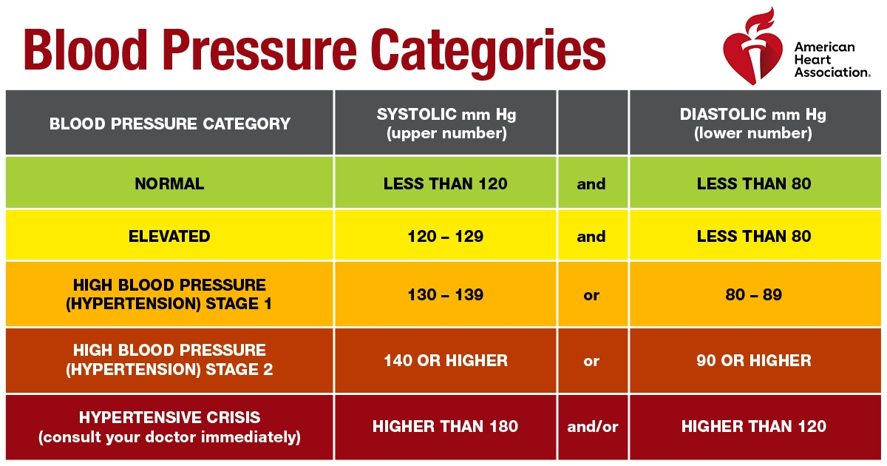

(Blood pressure chart, n.d)

**Appendix C:**

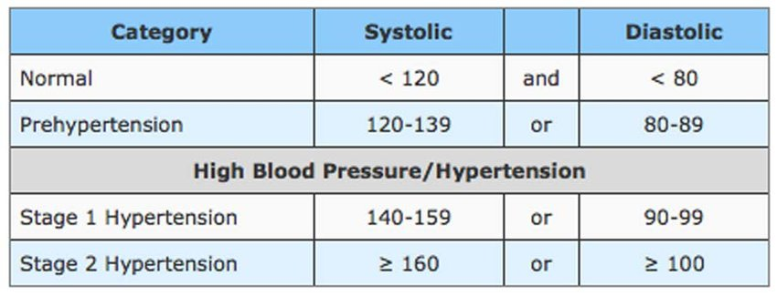

JNC 8 New Hypertension Management Guidelines. (Kovell, et al., 2021)

**Appendix D:**

**American College of Cardiology Cholesterol guideline**

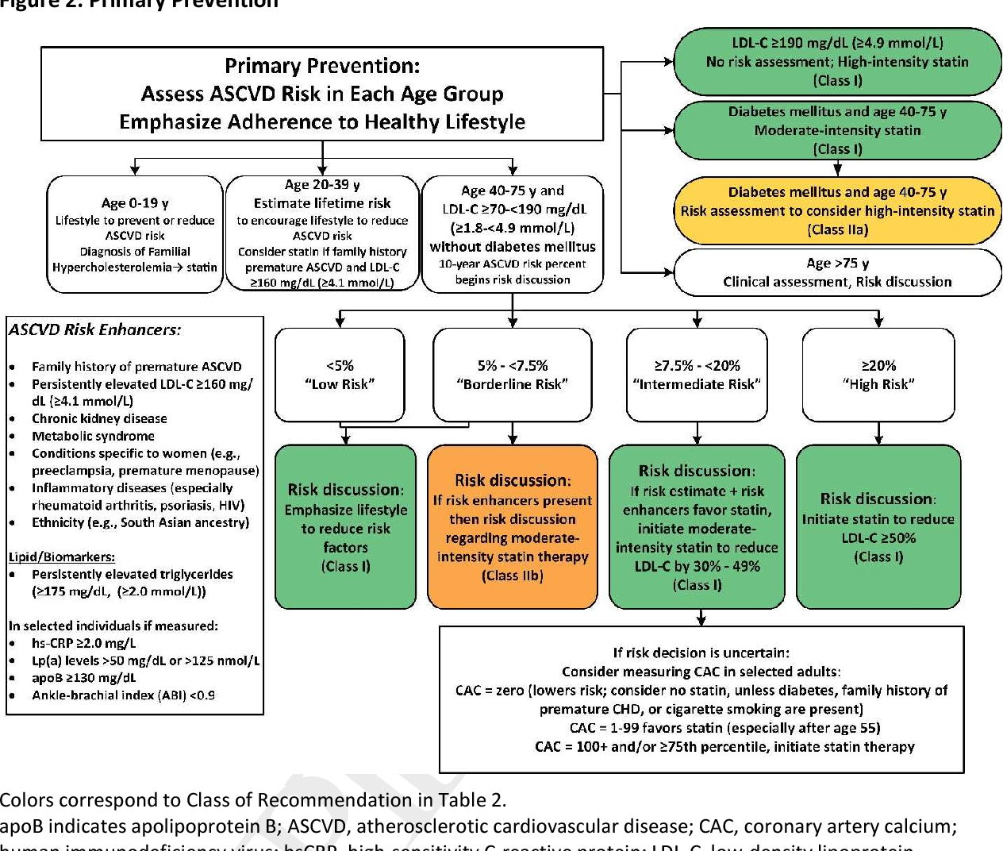

(Grundy, et al.,2019).

**Appendix E:**

**American Diabetes Association (ADA) hemoglobin A1C guideline**

|  |  |
| --- | --- |
| **Result** | **A1C** |
| **Normal** | less than 5.7% |
| **Prediabetes** | 5.7% to 6.4% |
| **Diabetes** | 6.5% or higher |

(American diabetes association, n.d.).

**Appendix F:**

**American Geriatrics Society (AGS) hemoglobin A1C guideline**

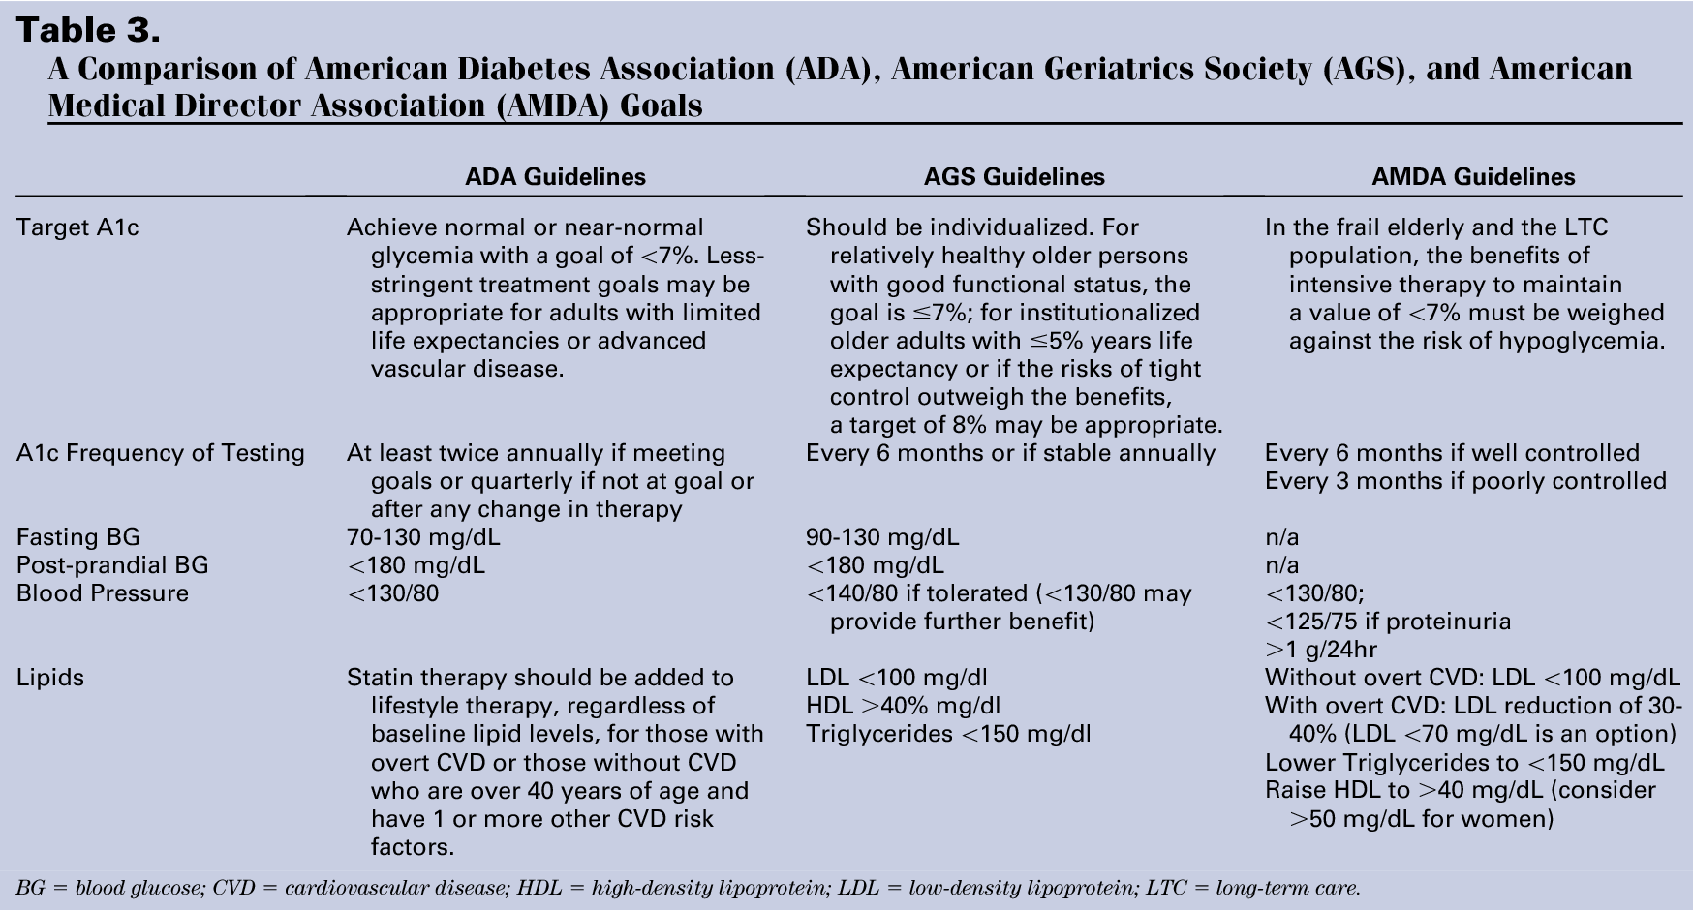

(Zarowitz, 2011).

**Appendix G:**

**Adult Treatment Panel III criteria.**

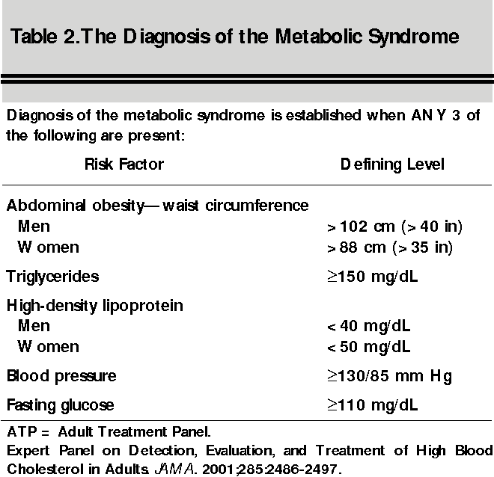

(Watson, 2002).

**Appendix H:**

**Fig. 1. The prevalence of MS patients among COVID-19 patients.**

P Value Distribution Chart.

Right-tailed p-value: P(Z > z) = 0.0002

Because the p-value (0.0002) is less than the significance level α=0.05, we reject the null hypothesis at 0.05 level of significance.

**Appendix I:**

**Support letter from Executive Director**.

**Appendix J:**

**IRB approval letter.**